**Introduction to Time Series**

Time Series is generally data which is collected over time and is dependent on it.

| **Count of cars** | **CO2 level** |
| --- | --- |
| C:\Users\kanik\AppData\Local\Packages\Microsoft.Office.Desktop_8wekyb3d8bbwe\AC\INetCache\Content.MSO\A00623E5.tmp | C:\Users\kanik\AppData\Local\Packages\Microsoft.Office.Desktop_8wekyb3d8bbwe\AC\INetCache\Content.MSO\4625643B.tmp |

Here we see that the count of cars is independent of time, hence it is not a time series. While the CO2 level increases with respect to time, hence it is a time series.

Formal definition of Time Series.

A series of data points collected in time order is known as a time series. Most of business houses work on time series data to analyse sales number for the next year, website traffic, count of traffic, number of calls received, etc. Data of a time series can be used for forecasting.

Not every data collected with respect to time represents a time series.

Some of the examples of time series are:

Stock Price :

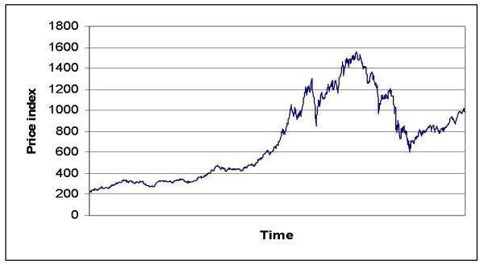

Passenger Count of an airlines:

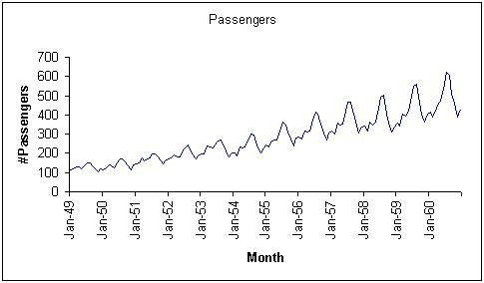

Temperature over time:

